 | Geophysical Instrument Pool Potsdam  Application for rental of instruments from the  "Gerätepool Geophysik" |  |  |  | 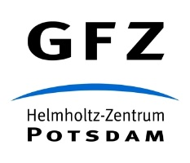
Date of application:
1. Name of project and acronym:

2. Applicant (name, institution, email):

3. Co – applicant(s) (name, institution):

4. Requested instrument type
Pickup date at GFZ: |  | Return to GFZ: |  | Time frame (alternative):
Type of recorder * / channel number: |  |  | Number of instruments:
Type of seismometer: |  |  | Number of instruments:
Equipment (discs, cable between disc and archive computer, other):

Notes:

5. Funding
a) Has an application for funding of the project been submitted? If yes, when and where?

b) Approval expected until:
c) If not yet, where and when planned?
d) From when to when will funding be available?
6. Short description of project (keywords of scientific aims; max 250 character):

7. Short outline of project (maximum of 2 extra pages) including
- Map of profile/station deployment
- Time plan of deployment
- Preparatory work (reconnaissance work)
* Explanatory statement if request for CUBE-recorder for long-term projects

8. Data archive
I conﬁrm, that I have submitted all data from previous experiments (since 2011) to GIPP- or GEFON-archive, according to the
terms of use

